

College of Computer Studies

**DATA STRUCTURES AND ALGORITHMS**

**(CCS0015L)**

**<TITLE OF YOUR PROJECT HERE>**

**GRADE**

*Submitted by:*

1X1

PICTURE

1X1

PICTURE

1X1

PICTURE

1X1

PICTURE

|  |  |  |  |
| --- | --- | --- | --- |
| LN, FN MI  Course  Section | LN, FN MI  Course  Section | LN, FN MI  Course  Section | LN, FN MI  Course  Section |
| *Submitted to:*  **<PROFESSOR’S NAME>**  Professor  Date of Defense | | | |

1. Introduction

Your introduction gives a general description of your project. It can be useful in establishing your thoughts and setting out the direction you intend your project to go in. State the reasons/problems encountered why you chose the project.

1. Description of the Project

This part states a description of the project – what it is all about. It should include a description of ALL the features present in the project.

.

1. Objectives

The Objectives of the study includes the responses to solve the main or overall problem presented. It must be broad enough to include all aspects of the subject matter to be suited or investigated; yet it must be brief and concise as possible.

Example:

1. To develop a program using C++ that enables to reserve customers their desired dates and rooms in the hotel.
2. To utilize advance programming concepts such as structure, file handling and pointers to implement the system.
3. Significance of the Study

This section the researchers expresses the value or the importance of the project. It is where the significant contribution of the results of the study is enumerated. It consists of explanation and discussion of the following: the rationale, timeless, and relevance of the study; who are the beneficiaries and what are their benefits; possible contribution to the body of knowledge and possible implications.

1. Project Details

This section consists of a table summarizing all the data structures/ADT used, algorithms, functions, files and classes with corresponding description.

Also, it should present a table summarizing the division of labor per team member.

**Table of Functions**

|  |  |  |
| --- | --- | --- |
| **Function Name** | **Scope**  **(Local / Global)** | **Purpose** |
|  |  |  |
|  |  |  |

**Table of Classes**

|  |  |  |
| --- | --- | --- |
| **Class Name** | **Scope**  **(Public /Private)** | **Purpose** |
|  |  |  |
|  |  |  |

**Table of Data Structures/ADT**

|  |  |  |
| --- | --- | --- |
| **Identifier Name** | **Type of Data Structure/**  **ADT Operations** | **Purpose** |
|  |  |  |
|  |  |  |

**Table of Algorithms**

|  |  |  |
| --- | --- | --- |
| **Algorithm Name** | **In what part of the program was it applied** | **Purpose** |
|  |  |  |
|  |  |  |

**Division of Labor**

|  |  |  |
| --- | --- | --- |
| **Function Name** | **Author/Developer** | **Date Completed** |
|  |  |  |
|  |  |  |

1. DATA ITEMS SPECIFICATION

Example:

|  |  |  |  |  |  |  |
| --- | --- | --- | --- | --- | --- | --- |
| **Data Item** | **Input/**  **Output** | **Data**  **Type** | **Length** | **Decimal** | **Formula**  **used** | **Allowed**  **Value** |
| studno | input | int | 4 | - | - | Numeric |
| name | input | string | - | - | - | Alphanumeric |
| gender | input | char | 1 | - | - | F, M |
| age | input | int | 2 | - | - | Range 18 – 30 |
| midgrd | input | float | 5 | 2 | - | Range 0 – 100 |
| fingrd | input | float | 5 | 2 | - | Range 0 – 100 |
| courseGrd | output | float | 5 | 2 | midgrd*0.30  +fingrd*0.70 | - |

1. Screen Output

This should include the screen outputs of the features of the project along with detailed explanations.

Example:

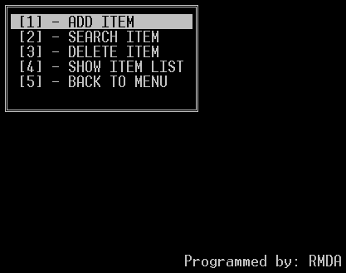

**Figure 1. Menu for Item Management**

Figure 1 shows the menu for item management that include the following:

1. **ADD ITEM** – this menu will add item from the list that includes the id, name, price, and quantity available.
2. **SEARCH ITEM** – this menu will ask the user to enter the id to be searched from the item list.
3. **DELETE ITEM** – this menu will ask the user to enter the id to be deleted from the list of items.
4. **SHOW ITEM LIST** – this menu will list down all items from the list.
5. **BACK TO MENU** – this option will go back to the main menu of the program.

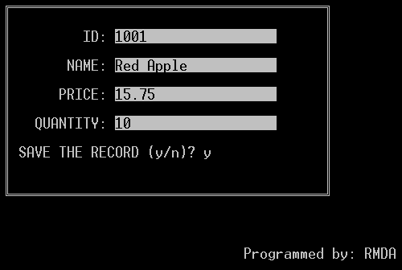

Figure 2 presents the add entry of the item. The system will ask the user if he or she wants to save the record.

1. Source Code

Upload both .cpp and .txt of your code.